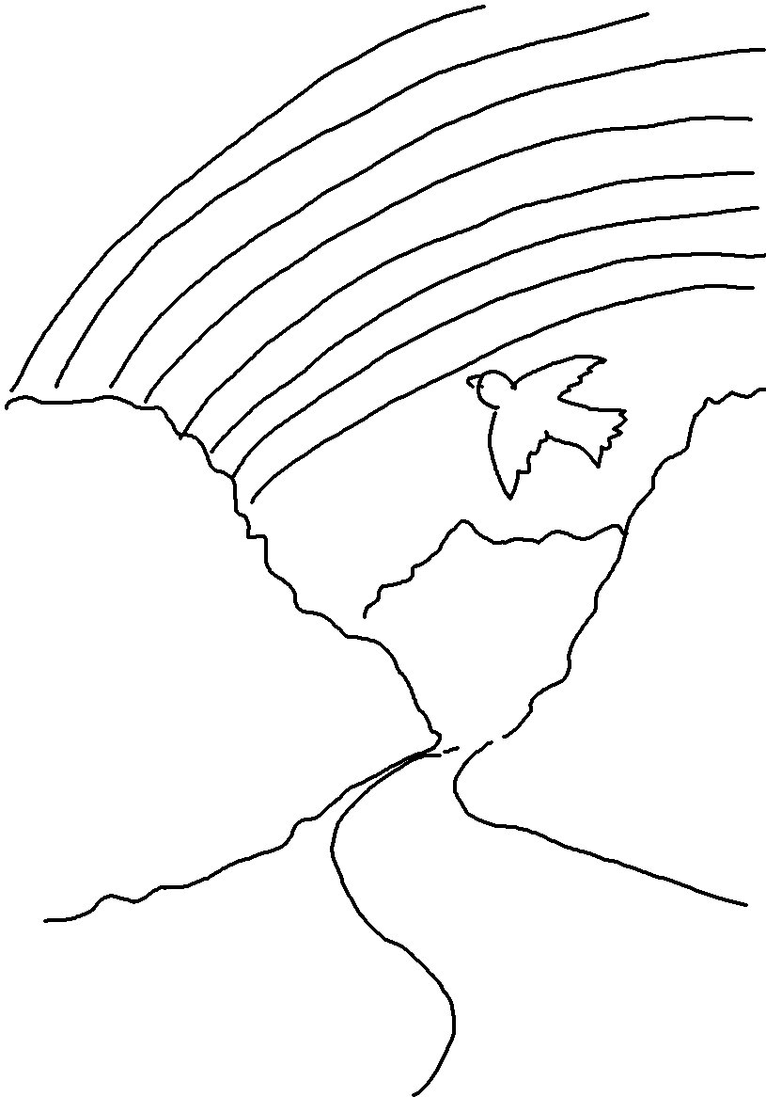
In Genesis 9:16_{NLT} God says, "When I see the rainbow in the clouds, I will remember…"

